Пензенский государственный университет

Кафедра «Вычислительная техника»

**Цель работы**

**ОТЧЕТ**

по лабораторной работе №5

по курсу «ЭВМ и ПУ»

на тему «Выполнение сдвигов и организация циклов»

**Выполнили:**

студенты группы 20ВВ2.1

Исаев С.Д.

Горбунов Н.А.

**Приняли:**

Коннов Н. Н.

Патунин Д. В.

Пенза 2022

Изучение принципов работы и методов проектирования процессоров. Изучение микропроцессорных БИС конкретных серий и выработка навыков практического проектирования микропроцессорных систем.

**Лабораторное задание**

Выполнение команды BIT, способы адресации – прямая индексная адресация(6), косвенно-регистровый метод адресации(1).

**Описание работы микропрограммы**

Основной алгоритм программы представлен на рисунке 1. На рисунке 4 представлен алгоритм выполнения команды BIT (код команды .36011).

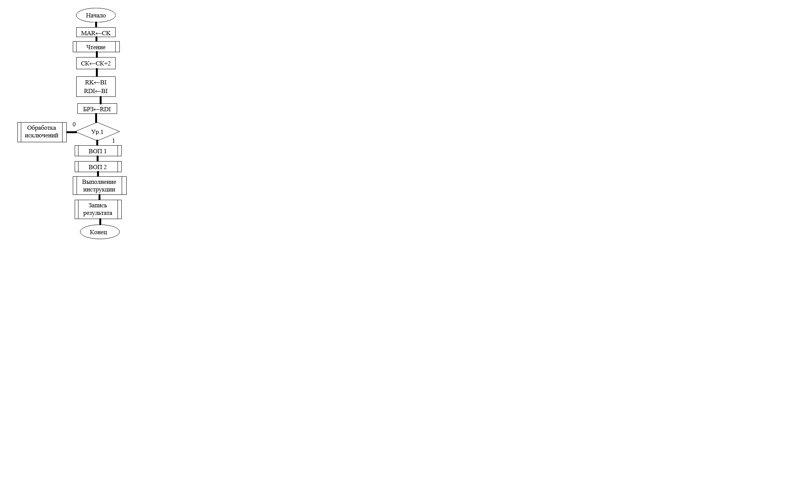

Рисунок 1 - Основной алгоритм.

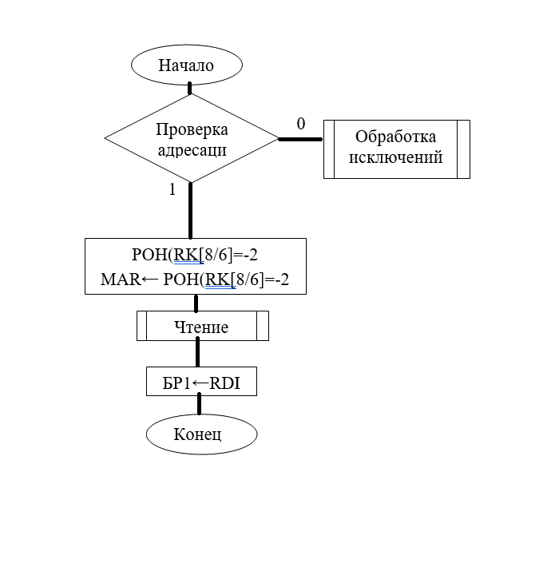

Рисунок 2 - Выборка первого операнда.

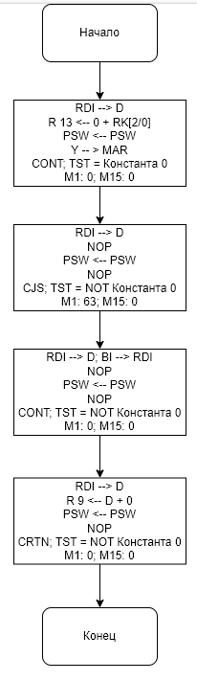

Рисунок 3 - Выборка второго операнда.

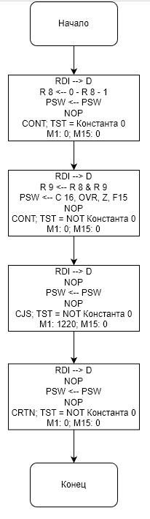

Рисунок 4 – Алгоритм выполнения команды BIT.

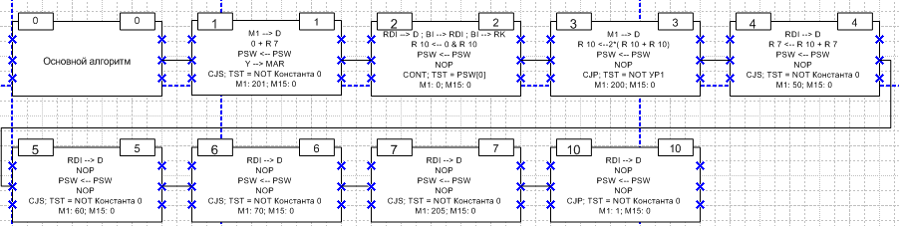

Рисунок 5 - ДМЛ основного алгоритма



Рисунок 6 - ДМЛ выборки первого операнда.

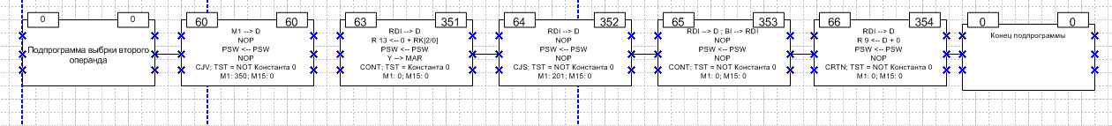

Рисунок 7 - ДМЛ выборки второго операнда.

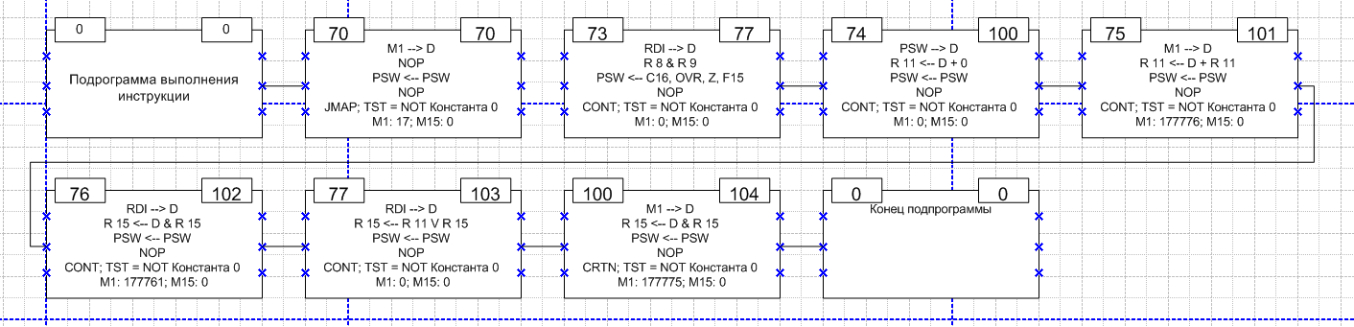

Рисунок 8 - ДМЛ подпрограммы дешифрации и выполнения команд первого уровня.

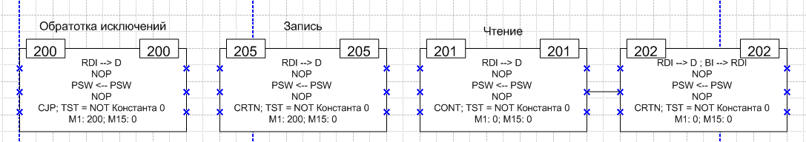

Рисунок 9 Подпрограммы чтения, записи, и обработки исключений

**Листинг:**

Адрес старта : 1

Адрес окончания моделирования : 10

Количество тактов моделирования : 100

Пошаговое моделирование

R0 = 42 R1 = 34 R2 = 0 R3 = 0 R4 = 0 R5 = 0

R6 = 0 R7 = 12344 R10 = 0 R11 = 0 R12 = 0 R13 = 0

R14 = 0 R15 = 0 R16 = 0 R17 = 0 RQ = 0 RK = 0

RDI = 0 RDO = 0 MAR = 0 BI = 36011 ZI = 0 DBC = 0

YBC = 0 CT = 0 DBU = 0 CMK = 2 RA = 0 ST0 = 0

ST1 = 0 ST2 = 0 ST3 = 0 PSW = 0 FLG = 0 C0 = 0

C16 = 0 OVR = 0 Z = 0 F15 = 0 TST = 0 PR15= 0

PR0 = 0 PQ15= 0 PQ0 = 0

Addr M1 M2 M3 M4 M5 M6 M7 M8 M9 M10 M11 M12 M13 M14 M15

1 201 1 7 1 7 12 0 0 4 0 1 2 0 2 0

Адрес следующей микрокоманды :201 TAKT= 1

R0 = 42 R1 = 34 R2 = 0 R3 = 0 R4 = 0 R5 = 0

R6 = 0 R7 = 12344 R10 = 0 R11 = 0 R12 = 0 R13 = 0

R14 = 0 R15 = 0 R16 = 0 R17 = 0 RQ = 0 RK = 0

RDI = 0 RDO = 0 MAR = 12344 BI = 36011 ZI = 0 DBC = 201

YBC = 12344 CT = 0 DBU = 201 CMK = 202 RA = 201 ST0 = 2

ST1 = 0 ST2 = 0 ST3 = 0 PSW = 0 FLG = 0 C0 = 0

C16 = 0 OVR = 0 Z = 0 F15 = 0 TST = 1 PR15= 0

PR0 = 1 PQ15= 0 PQ0 = 1

Addr M1 M2 M3 M4 M5 M6 M7 M8 M9 M10 M11 M12 M13 M14 M15

201 0 1 7 16 0 0 0 0 0 0 0 0 0 0 0

Адрес следующей микрокоманды :202 TAKT= 2

R0 = 42 R1 = 34 R2 = 0 R3 = 0 R4 = 0 R5 = 0

R6 = 0 R7 = 12344 R10 = 0 R11 = 0 R12 = 0 R13 = 0

R14 = 0 R15 = 0 R16 = 0 R17 = 0 RQ = 42 RK = 0

RDI = 0 RDO = 0 MAR = 12344 BI = 36011 ZI = 0 DBC = 0

YBC = 42 CT = 0 DBU = 0 CMK = 203 RA = 0 ST0 = 2

ST1 = 0 ST2 = 0 ST3 = 0 PSW = 0 FLG = 0 C0 = 0

C16 = 0 OVR = 0 Z = 0 F15 = 0 TST = 1 PR15= 0

PR0 = 1 PQ15= 0 PQ0 = 1

Addr M1 M2 M3 M4 M5 M6 M7 M8 M9 M10 M11 M12 M13 M14 M15

202 0 1 7 12 0 0 0 0 0 0 0 4 0 0 0

Адрес следующей микрокоманды :2 TAKT= 3

R0 = 42 R1 = 34 R2 = 0 R3 = 0 R4 = 0 R5 = 0

R6 = 0 R7 = 12344 R10 = 0 R11 = 0 R12 = 0 R13 = 0

R14 = 0 R15 = 0 R16 = 0 R17 = 0 RQ = 104 RK = 0

RDI = 36011 RDO = 0 MAR = 12344 BI = 36011 ZI = 0 DBC = 0

YBC = 104 CT = 0 DBU = 0 CMK = 3 RA = 0 ST0 = 0

ST1 = 0 ST2 = 0 ST3 = 2 PSW = 0 FLG = 0 C0 = 0

C16 = 0 OVR = 0 Z = 0 F15 = 0 TST = 1 PR15= 0

PR0 = 1 PQ15= 0 PQ0 = 1

Addr M1 M2 M3 M4 M5 M6 M7 M8 M9 M10 M11 M12 M13 M14 M15

2 0 0 0 16 12 12 0 0 4 4 2 7 0 0 0

Адрес следующей микрокоманды :3 TAKT= 4

R0 = 42 R1 = 34 R2 = 0 R3 = 0 R4 = 0 R5 = 0

R6 = 0 R7 = 12344 R10 = 0 R11 = 0 R12 = 0 R13 = 0

R14 = 0 R15 = 0 R16 = 0 R17 = 0 RQ = 104 RK = 36011

RDI = 36011 RDO = 0 MAR = 12344 BI = 36011 ZI = 0 DBC = 36011

YBC = 0 CT = 0 DBU = 0 CMK = 4 RA = 0 ST0 = 0

ST1 = 0 ST2 = 0 ST3 = 2 PSW = 0 FLG = 0 C0 = 0

C16 = 0 OVR = 0 Z = 1 F15 = 0 TST = 0 PR15= 1

PR0 = 0 PQ15= 1 PQ0 = 0

Addr M1 M2 M3 M4 M5 M6 M7 M8 M9 M10 M11 M12 M13 M14 M15

3 200 3 10 3 12 12 0 1 1 0 7 2 0 0 0

Адрес следующей микрокоманды :4 TAKT= 5

R0 = 42 R1 = 34 R2 = 0 R3 = 0 R4 = 0 R5 = 0

R6 = 0 R7 = 12344 R10 = 0 R11 = 0 R12 = 2 R13 = 0

R14 = 0 R15 = 0 R16 = 0 R17 = 0 RQ = 104 RK = 36011

RDI = 36011 RDO = 0 MAR = 12344 BI = 36011 ZI = 0 DBC = 200

YBC = 1 CT = 0 DBU = 200 CMK = 5 RA = 200 ST0 = 0

ST1 = 0 ST2 = 0 ST3 = 2 PSW = 0 FLG = 0 C0 = 1

C16 = 0 OVR = 0 Z = 0 F15 = 0 TST = 0 PR15= 0

PR0 = 0 PQ15= 0 PQ0 = 0

Addr M1 M2 M3 M4 M5 M6 M7 M8 M9 M10 M11 M12 M13 M14 M15

4 50 1 7 1 12 7 0 0 1 0 3 0 0 0 0

Адрес следующей микрокоманды :50 TAKT= 6

R0 = 42 R1 = 34 R2 = 0 R3 = 0 R4 = 0 R5 = 0

R6 = 0 R7 = 12346 R10 = 0 R11 = 0 R12 = 2 R13 = 0

R14 = 0 R15 = 0 R16 = 0 R17 = 0 RQ = 104 RK = 36011

RDI = 36011 RDO = 0 MAR = 12344 BI = 36011 ZI = 0 DBC = 36011

YBC = 12346 CT = 0 DBU = 50 CMK = 51 RA = 50 ST0 = 5

ST1 = 0 ST2 = 0 ST3 = 0 PSW = 0 FLG = 0 C0 = 0

C16 = 0 OVR = 0 Z = 0 F15 = 0 TST = 1 PR15= 1

PR0 = 0 PQ15= 1 PQ0 = 0

Addr M1 M2 M3 M4 M5 M6 M7 M8 M9 M10 M11 M12 M13 M14 M15

50 375 3 7 2 0 0 0 0 0 0 0 2 0 0 0

Адрес следующей микрокоманды :375 TAKT= 7

R0 = 42 R1 = 34 R2 = 0 R3 = 0 R4 = 0 R5 = 0

R6 = 0 R7 = 12346 R10 = 0 R11 = 0 R12 = 2 R13 = 0

R14 = 0 R15 = 0 R16 = 0 R17 = 0 RQ = 146 RK = 36011

RDI = 36011 RDO = 0 MAR = 12344 BI = 36011 ZI = 0 DBC = 375

YBC = 146 CT = 0 DBU = 74 CMK = 376 RA = 74 ST0 = 5

ST1 = 0 ST2 = 0 ST3 = 0 PSW = 0 FLG = 0 C0 = 0

C16 = 0 OVR = 0 Z = 0 F15 = 0 TST = 1 PR15= 0

PR0 = 1 PQ15= 0 PQ0 = 1

Addr M1 M2 M3 M4 M5 M6 M7 M8 M9 M10 M11 M12 M13 M14 M15

375 2 1 7 16 7 7 2 0 5 0 2 2 0 2 0

Адрес следующей микрокоманды :376 TAKT= 8

R0 = 42 R1 = 34 R2 = 0 R3 = 0 R4 = 0 R5 = 0

R6 = 0 R7 = 12350 R10 = 0 R11 = 0 R12 = 2 R13 = 0

R14 = 0 R15 = 0 R16 = 0 R17 = 0 RQ = 146 RK = 36011

RDI = 36011 RDO = 0 MAR = 12346 BI = 36011 ZI = 0 DBC = 2

YBC = 12346 CT = 0 DBU = 2 CMK = 377 RA = 2 ST0 = 5

ST1 = 0 ST2 = 0 ST3 = 0 PSW = 0 FLG = 0 C0 = 0

C16 = 0 OVR = 0 Z = 0 F15 = 0 TST = 1 PR15= 1

PR0 = 1 PQ15= 1 PQ0 = 1

Addr M1 M2 M3 M4 M5 M6 M7 M8 M9 M10 M11 M12 M13 M14 M15

376 201 0 7 1 0 0 0 0 0 0 0 0 0 0 0

Адрес следующей микрокоманды :377 TAKT= 9

R0 = 42 R1 = 34 R2 = 0 R3 = 0 R4 = 0 R5 = 0

R6 = 0 R7 = 12350 R10 = 0 R11 = 0 R12 = 2 R13 = 0

R14 = 0 R15 = 0 R16 = 0 R17 = 0 RQ = 210 RK = 36011

RDI = 36011 RDO = 0 MAR = 12346 BI = 36011 ZI = 0 DBC = 36011

YBC = 210 CT = 0 DBU = 201 CMK = 400 RA = 201 ST0 = 5

ST1 = 0 ST2 = 0 ST3 = 0 PSW = 0 FLG = 0 C0 = 0

C16 = 0 OVR = 0 Z = 0 F15 = 0 TST = 0 PR15= 0

PR0 = 1 PQ15= 0 PQ0 = 1

Addr M1 M2 M3 M4 M5 M6 M7 M8 M9 M10 M11 M12 M13 M14 M15

377 0 1 7 16 0 10 0 0 7 0 0 4 0 0 0

Адрес следующей микрокоманды :400 TAKT= 10

R0 = 42 R1 = 34 R2 = 0 R3 = 0 R4 = 0 R5 = 0

R6 = 0 R7 = 12350 R10 = 0 R11 = 0 R12 = 2 R13 = 0

R14 = 0 R15 = 0 R16 = 0 R17 = 0 RQ = 36011 RK = 36011

RDI = 36011 RDO = 0 MAR = 12346 BI = 36011 ZI = 0 DBC = 36011

YBC = 36011 CT = 0 DBU = 0 CMK = 401 RA = 0 ST0 = 5

ST1 = 0 ST2 = 0 ST3 = 0 PSW = 0 FLG = 0 C0 = 0

C16 = 0 OVR = 0 Z = 0 F15 = 0 TST = 1 PR15= 0

PR0 = 1 PQ15= 0 PQ0 = 1

Addr M1 M2 M3 M4 M5 M6 M7 M8 M9 M10 M11 M12 M13 M14 M15

400 201 1 7 1 30 0 0 0 5 0 1 0 0 0 0

Адрес следующей микрокоманды :201 TAKT= 11

R0 = 42 R1 = 34 R2 = 0 R3 = 0 R4 = 0 R5 = 0

R6 = 0 R7 = 12350 R10 = 0 R11 = 0 R12 = 2 R13 = 0

R14 = 0 R15 = 0 R16 = 0 R17 = 0 RQ = 36011 RK = 36011

RDI = 36011 RDO = 0 MAR = 12346 BI = 36011 ZI = 0 DBC = 36011

YBC = 36053 CT = 0 DBU = 201 CMK = 202 RA = 201 ST0 = 401

ST1 = 5 ST2 = 0 ST3 = 0 PSW = 0 FLG = 0 C0 = 0

C16 = 0 OVR = 0 Z = 0 F15 = 0 TST = 1 PR15= 0

PR0 = 1 PQ15= 0 PQ0 = 1

Addr M1 M2 M3 M4 M5 M6 M7 M8 M9 M10 M11 M12 M13 M14 M15

201 0 1 7 16 0 0 0 0 0 0 0 0 0 0 0

Адрес следующей микрокоманды :202 TAKT= 12

R0 = 42 R1 = 34 R2 = 0 R3 = 0 R4 = 0 R5 = 0

R6 = 0 R7 = 12350 R10 = 0 R11 = 0 R12 = 2 R13 = 0

R14 = 0 R15 = 0 R16 = 0 R17 = 0 RQ = 36053 RK = 36011

RDI = 36011 RDO = 0 MAR = 12346 BI = 2222 ZI = 0 DBC = 36011

YBC = 36053 CT = 0 DBU = 0 CMK = 203 RA = 0 ST0 = 401

ST1 = 5 ST2 = 0 ST3 = 0 PSW = 0 FLG = 0 C0 = 0

C16 = 0 OVR = 0 Z = 0 F15 = 0 TST = 1 PR15= 0

PR0 = 1 PQ15= 0 PQ0 = 1

Addr M1 M2 M3 M4 M5 M6 M7 M8 M9 M10 M11 M12 M13 M14 M15

202 0 1 7 12 0 0 0 0 0 0 0 4 0 0 0

Адрес следующей микрокоманды :401 TAKT= 13

R0 = 42 R1 = 34 R2 = 0 R3 = 0 R4 = 0 R5 = 0

R6 = 0 R7 = 12350 R10 = 0 R11 = 0 R12 = 2 R13 = 0

R14 = 0 R15 = 0 R16 = 0 R17 = 0 RQ = 36115 RK = 36011

RDI = 2222 RDO = 0 MAR = 12346 BI = 2222 ZI = 0 DBC = 36011

YBC = 36115 CT = 0 DBU = 0 CMK = 402 RA = 0 ST0 = 5

ST1 = 0 ST2 = 0 ST3 = 401 PSW = 0 FLG = 0 C0 = 0

C16 = 0 OVR = 0 Z = 0 F15 = 0 TST = 1 PR15= 0

PR0 = 1 PQ15= 0 PQ0 = 1

Addr M1 M2 M3 M4 M5 M6 M7 M8 M9 M10 M11 M12 M13 M14 M15

401 0 1 7 16 30 0 0 0 5 0 0 0 0 0 0

Адрес следующей микрокоманды :402 TAKT= 14

R0 = 42 R1 = 34 R2 = 0 R3 = 0 R4 = 0 R5 = 0

R6 = 0 R7 = 12350 R10 = 0 R11 = 0 R12 = 2 R13 = 0

R14 = 0 R15 = 0 R16 = 0 R17 = 0 RQ = 2264 RK = 36011

RDI = 2222 RDO = 0 MAR = 12346 BI = 2222 ZI = 0 DBC = 2222

YBC = 2264 CT = 0 DBU = 0 CMK = 403 RA = 0 ST0 = 5

ST1 = 0 ST2 = 0 ST3 = 401 PSW = 0 FLG = 0 C0 = 0

C16 = 0 OVR = 0 Z = 0 F15 = 0 TST = 1 PR15= 0

PR0 = 1 PQ15= 0 PQ0 = 1

Addr M1 M2 M3 M4 M5 M6 M7 M8 M9 M10 M11 M12 M13 M14 M15

402 0 1 7 16 0 0 0 0 0 0 0 4 0 0 0

Адрес следующей микрокоманды :403 TAKT= 15

R0 = 42 R1 = 34 R2 = 0 R3 = 0 R4 = 0 R5 = 0

R6 = 0 R7 = 12350 R10 = 0 R11 = 0 R12 = 2 R13 = 0

R14 = 0 R15 = 0 R16 = 0 R17 = 0 RQ = 2326 RK = 36011

RDI = 2222 RDO = 0 MAR = 12346 BI = 2222 ZI = 0 DBC = 2222

YBC = 2326 CT = 0 DBU = 0 CMK = 404 RA = 0 ST0 = 5

ST1 = 0 ST2 = 0 ST3 = 401 PSW = 0 FLG = 0 C0 = 0

C16 = 0 OVR = 0 Z = 0 F15 = 0 TST = 1 PR15= 0

PR0 = 1 PQ15= 0 PQ0 = 1

Addr M1 M2 M3 M4 M5 M6 M7 M8 M9 M10 M11 M12 M13 M14 M15

403 0 1 7 12 0 10 0 0 7 0 2 0 0 0 0

Адрес следующей микрокоманды :5 TAKT= 16

R0 = 42 R1 = 34 R2 = 0 R3 = 0 R4 = 0 R5 = 0

R6 = 0 R7 = 12350 R10 = 2222 R11 = 0 R12 = 2 R13 = 0

R14 = 0 R15 = 0 R16 = 0 R17 = 0 RQ = 2326 RK = 36011

RDI = 2222 RDO = 0 MAR = 12346 BI = 2222 ZI = 0 DBC = 2222

YBC = 42 CT = 0 DBU = 0 CMK = 6 RA = 0 ST0 = 0

ST1 = 0 ST2 = 401 ST3 = 5 PSW = 0 FLG = 0 C0 = 0

C16 = 0 OVR = 0 Z = 0 F15 = 0 TST = 1 PR15= 1

PR0 = 0 PQ15= 1 PQ0 = 0

Addr M1 M2 M3 M4 M5 M6 M7 M8 M9 M10 M11 M12 M13 M14 M15

5 60 1 7 1 0 0 0 0 0 0 0 0 0 0 0

Адрес следующей микрокоманды :60 TAKT= 17

R0 = 42 R1 = 34 R2 = 0 R3 = 0 R4 = 0 R5 = 0

R6 = 0 R7 = 12350 R10 = 2222 R11 = 0 R12 = 2 R13 = 0

R14 = 0 R15 = 0 R16 = 0 R17 = 0 RQ = 2370 RK = 36011

RDI = 2222 RDO = 0 MAR = 12346 BI = 2222 ZI = 0 DBC = 2222

YBC = 2370 CT = 0 DBU = 60 CMK = 61 RA = 60 ST0 = 6

ST1 = 0 ST2 = 0 ST3 = 401 PSW = 0 FLG = 0 C0 = 0

C16 = 0 OVR = 0 Z = 0 F15 = 0 TST = 1 PR15= 0

PR0 = 1 PQ15= 0 PQ0 = 1

Addr M1 M2 M3 M4 M5 M6 M7 M8 M9 M10 M11 M12 M13 M14 M15

60 350 3 7 6 0 0 0 0 0 0 0 2 0 0 0

Адрес следующей микрокоманды :351 TAKT= 18

R0 = 42 R1 = 34 R2 = 0 R3 = 0 R4 = 0 R5 = 0

R6 = 0 R7 = 12350 R10 = 2222 R11 = 0 R12 = 2 R13 = 0

R14 = 0 R15 = 0 R16 = 0 R17 = 0 RQ = 2432 RK = 36011

RDI = 2222 RDO = 0 MAR = 12346 BI = 2222 ZI = 0 DBC = 350

YBC = 2432 CT = 0 DBU = 11 CMK = 352 RA = 11 ST0 = 6

ST1 = 0 ST2 = 0 ST3 = 401 PSW = 0 FLG = 0 C0 = 0

C16 = 0 OVR = 0 Z = 0 F15 = 0 TST = 1 PR15= 0

PR0 = 1 PQ15= 0 PQ0 = 1

Addr M1 M2 M3 M4 M5 M6 M7 M8 M9 M10 M11 M12 M13 M14 M15

351 0 0 7 16 20 15 0 0 4 0 3 0 0 2 0

Адрес следующей микрокоманды :352 TAKT= 19

R0 = 42 R1 = 34 R2 = 0 R3 = 0 R4 = 0 R5 = 0

R6 = 0 R7 = 12350 R10 = 2222 R11 = 0 R12 = 2 R13 = 0

R14 = 0 R15 = 34 R16 = 0 R17 = 0 RQ = 2432 RK = 36011

RDI = 2222 RDO = 0 MAR = 34 BI = 2222 ZI = 0 DBC = 2222

YBC = 34 CT = 0 DBU = 0 CMK = 353 RA = 0 ST0 = 6

ST1 = 0 ST2 = 0 ST3 = 401 PSW = 0 FLG = 0 C0 = 0

C16 = 0 OVR = 0 Z = 0 F15 = 0 TST = 0 PR15= 1

PR0 = 0 PQ15= 1 PQ0 = 0

Addr M1 M2 M3 M4 M5 M6 M7 M8 M9 M10 M11 M12 M13 M14 M15

352 201 1 7 1 13 20 0 1 1 1 0 0 0 0 0

Адрес следующей микрокоманды :201 TAKT= 20

R0 = 42 R1 = 34 R2 = 0 R3 = 0 R4 = 0 R5 = 0

R6 = 0 R7 = 12350 R10 = 2222 R11 = 0 R12 = 2 R13 = 0

R14 = 0 R15 = 34 R16 = 0 R17 = 0 RQ = 34 RK = 36011

RDI = 2222 RDO = 0 MAR = 34 BI = 2222 ZI = 0 DBC = 2222

YBC = 34 CT = 0 DBU = 201 CMK = 202 RA = 201 ST0 = 353

ST1 = 6 ST2 = 0 ST3 = 0 PSW = 0 FLG = 0 C0 = 1

C16 = 1 OVR = 0 Z = 0 F15 = 0 TST = 1 PR15= 0

PR0 = 1 PQ15= 0 PQ0 = 1

Addr M1 M2 M3 M4 M5 M6 M7 M8 M9 M10 M11 M12 M13 M14 M15

201 0 1 7 16 0 0 0 0 0 0 0 0 0 0 0

Адрес следующей микрокоманды :202 TAKT= 21

R0 = 42 R1 = 34 R2 = 0 R3 = 0 R4 = 0 R5 = 0

R6 = 0 R7 = 12350 R10 = 2222 R11 = 0 R12 = 2 R13 = 0

R14 = 0 R15 = 34 R16 = 0 R17 = 0 RQ = 76 RK = 36011

RDI = 2222 RDO = 0 MAR = 34 BI = 4444 ZI = 0 DBC = 2222

YBC = 76 CT = 0 DBU = 0 CMK = 203 RA = 0 ST0 = 353

ST1 = 6 ST2 = 0 ST3 = 0 PSW = 0 FLG = 0 C0 = 0

C16 = 0 OVR = 0 Z = 0 F15 = 0 TST = 1 PR15= 0

PR0 = 1 PQ15= 0 PQ0 = 1

Addr M1 M2 M3 M4 M5 M6 M7 M8 M9 M10 M11 M12 M13 M14 M15

202 0 1 7 12 0 0 0 0 0 0 0 4 0 0 0

Адрес следующей микрокоманды :353 TAKT= 22

R0 = 42 R1 = 34 R2 = 0 R3 = 0 R4 = 0 R5 = 0

R6 = 0 R7 = 12350 R10 = 2222 R11 = 0 R12 = 2 R13 = 0

R14 = 0 R15 = 34 R16 = 0 R17 = 0 RQ = 140 RK = 36011

RDI = 4444 RDO = 0 MAR = 34 BI = 4444 ZI = 0 DBC = 2222

YBC = 140 CT = 0 DBU = 0 CMK = 354 RA = 0 ST0 = 6

ST1 = 0 ST2 = 0 ST3 = 353 PSW = 0 FLG = 0 C0 = 0

C16 = 0 OVR = 0 Z = 0 F15 = 0 TST = 1 PR15= 0

PR0 = 1 PQ15= 0 PQ0 = 1

Addr M1 M2 M3 M4 M5 M6 M7 M8 M9 M10 M11 M12 M13 M14 M15

353 0 1 7 16 0 0 0 0 0 0 0 4 0 0 0

Адрес следующей микрокоманды :354 TAKT= 23

R0 = 42 R1 = 34 R2 = 0 R3 = 0 R4 = 0 R5 = 0

R6 = 0 R7 = 12350 R10 = 2222 R11 = 0 R12 = 2 R13 = 0

R14 = 0 R15 = 34 R16 = 0 R17 = 0 RQ = 202 RK = 36011

RDI = 4444 RDO = 0 MAR = 34 BI = 4444 ZI = 0 DBC = 4444

YBC = 202 CT = 0 DBU = 0 CMK = 355 RA = 0 ST0 = 6

ST1 = 0 ST2 = 0 ST3 = 353 PSW = 0 FLG = 0 C0 = 0

C16 = 0 OVR = 0 Z = 0 F15 = 0 TST = 1 PR15= 0

PR0 = 1 PQ15= 0 PQ0 = 1

Addr M1 M2 M3 M4 M5 M6 M7 M8 M9 M10 M11 M12 M13 M14 M15

354 0 1 7 12 0 11 0 0 7 0 3 0 0 0 0

Адрес следующей микрокоманды :6 TAKT= 24

R0 = 42 R1 = 34 R2 = 0 R3 = 0 R4 = 0 R5 = 0

R6 = 0 R7 = 12350 R10 = 2222 R11 = 4444 R12 = 2 R13 = 0

R14 = 0 R15 = 34 R16 = 0 R17 = 0 RQ = 202 RK = 36011

RDI = 4444 RDO = 0 MAR = 34 BI = 4444 ZI = 0 DBC = 4444

YBC = 4444 CT = 0 DBU = 0 CMK = 7 RA = 0 ST0 = 0

ST1 = 0 ST2 = 353 ST3 = 6 PSW = 0 FLG = 0 C0 = 0

C16 = 0 OVR = 0 Z = 0 F15 = 0 TST = 1 PR15= 1

PR0 = 0 PQ15= 1 PQ0 = 0

Addr M1 M2 M3 M4 M5 M6 M7 M8 M9 M10 M11 M12 M13 M14 M15

6 70 1 7 1 0 0 0 0 0 0 0 0 0 0 0

Адрес следующей микрокоманды :70 TAKT= 25

R0 = 42 R1 = 34 R2 = 0 R3 = 0 R4 = 0 R5 = 0

R6 = 0 R7 = 12350 R10 = 2222 R11 = 4444 R12 = 2 R13 = 0

R14 = 0 R15 = 34 R16 = 0 R17 = 0 RQ = 244 RK = 36011

RDI = 4444 RDO = 0 MAR = 34 BI = 4444 ZI = 0 DBC = 4444

YBC = 244 CT = 0 DBU = 70 CMK = 71 RA = 70 ST0 = 7

ST1 = 0 ST2 = 0 ST3 = 353 PSW = 0 FLG = 0 C0 = 0

C16 = 0 OVR = 0 Z = 0 F15 = 0 TST = 1 PR15= 0

PR0 = 1 PQ15= 0 PQ0 = 1

Addr M1 M2 M3 M4 M5 M6 M7 M8 M9 M10 M11 M12 M13 M14 M15

70 17 3 7 2 0 0 0 0 0 0 0 2 0 0 0

Адрес следующей микрокоманды :77 TAKT= 26

R0 = 42 R1 = 34 R2 = 0 R3 = 0 R4 = 0 R5 = 0

R6 = 0 R7 = 12350 R10 = 2222 R11 = 4444 R12 = 2 R13 = 0

R14 = 0 R15 = 34 R16 = 0 R17 = 0 RQ = 306 RK = 36011

RDI = 4444 RDO = 0 MAR = 34 BI = 4444 ZI = 0 DBC = 17

YBC = 306 CT = 0 DBU = 74 CMK = 100 RA = 74 ST0 = 7

ST1 = 0 ST2 = 0 ST3 = 353 PSW = 0 FLG = 0 C0 = 0

C16 = 0 OVR = 0 Z = 0 F15 = 0 TST = 1 PR15= 0

PR0 = 1 PQ15= 0 PQ0 = 1

Addr M1 M2 M3 M4 M5 M6 M7 M8 M9 M10 M11 M12 M13 M14 M15

77 0 1 7 16 10 11 0 0 1 4 1 0 1 0 0

Адрес следующей микрокоманды :100 TAKT= 27

R0 = 42 R1 = 34 R2 = 0 R3 = 0 R4 = 0 R5 = 0

R6 = 0 R7 = 12350 R10 = 2222 R11 = 4444 R12 = 2 R13 = 0

R14 = 0 R15 = 34 R16 = 0 R17 = 0 RQ = 306 RK = 36011

RDI = 4444 RDO = 0 MAR = 34 BI = 4444 ZI = 0 DBC = 4444

YBC = 0 CT = 0 DBU = 0 CMK = 101 RA = 0 ST0 = 7

ST1 = 0 ST2 = 0 ST3 = 353 PSW = 4 FLG = 0 C0 = 0

C16 = 0 OVR = 0 Z = 1 F15 = 0 TST = 1 PR15= 0

PR0 = 1 PQ15= 0 PQ0 = 1

Addr M1 M2 M3 M4 M5 M6 M7 M8 M9 M10 M11 M12 M13 M14 M15

100 0 1 7 16 0 13 0 0 7 0 3 3 0 0 0

Адрес следующей микрокоманды :101 TAKT= 28

R0 = 42 R1 = 34 R2 = 0 R3 = 0 R4 = 0 R5 = 0

R6 = 0 R7 = 12350 R10 = 2222 R11 = 4444 R12 = 2 R13 = 4

R14 = 0 R15 = 34 R16 = 0 R17 = 0 RQ = 306 RK = 36011

RDI = 4444 RDO = 0 MAR = 34 BI = 4444 ZI = 0 DBC = 4

YBC = 4 CT = 0 DBU = 0 CMK = 102 RA = 0 ST0 = 7

ST1 = 0 ST2 = 0 ST3 = 353 PSW = 4 FLG = 0 C0 = 0

C16 = 0 OVR = 0 Z = 0 F15 = 0 TST = 1 PR15= 1

PR0 = 0 PQ15= 1 PQ0 = 0

Addr M1 M2 M3 M4 M5 M6 M7 M8 M9 M10 M11 M12 M13 M14 M15

101 177776 1 7 16 13 13 0 0 5 0 3 2 0 0 0

Адрес следующей микрокоманды :102 TAKT= 29

R0 = 42 R1 = 34 R2 = 0 R3 = 0 R4 = 0 R5 = 0

R6 = 0 R7 = 12350 R10 = 2222 R11 = 4444 R12 = 2 R13 = 2

R14 = 0 R15 = 34 R16 = 0 R17 = 0 RQ = 306 RK = 36011

RDI = 4444 RDO = 0 MAR = 34 BI = 4444 ZI = 0 DBC =177776

YBC = 2 CT = 0 DBU = 7776 CMK = 103 RA = 7776 ST0 = 7

ST1 = 0 ST2 = 0 ST3 = 353 PSW = 4 FLG = 0 C0 = 0

C16 = 1 OVR = 0 Z = 0 F15 = 0 TST = 1 PR15= 1

PR0 = 0 PQ15= 1 PQ0 = 0

Addr M1 M2 M3 M4 M5 M6 M7 M8 M9 M10 M11 M12 M13 M14 M15

102 177761 1 7 16 17 17 0 0 5 4 3 0 0 0 0

Адрес следующей микрокоманды :103 TAKT= 30

R0 = 42 R1 = 34 R2 = 0 R3 = 0 R4 = 0 R5 = 0

R6 = 0 R7 = 12350 R10 = 2222 R11 = 4444 R12 = 2 R13 = 2

R14 = 0 R15 = 34 R16 = 0 R17 = 0 RQ = 306 RK = 36011

RDI = 4444 RDO = 0 MAR = 34 BI = 4444 ZI = 0 DBC = 4444

YBC = 0 CT = 0 DBU = 7761 CMK = 104 RA = 7761 ST0 = 7

ST1 = 0 ST2 = 0 ST3 = 353 PSW = 4 FLG = 0 C0 = 0

C16 = 0 OVR = 0 Z = 1 F15 = 0 TST = 1 PR15= 1

PR0 = 0 PQ15= 1 PQ0 = 0

Addr M1 M2 M3 M4 M5 M6 M7 M8 M9 M10 M11 M12 M13 M14 M15

103 0 1 7 16 13 17 0 0 1 3 3 0 0 0 0

Адрес следующей микрокоманды :104 TAKT= 31

R0 = 42 R1 = 34 R2 = 0 R3 = 0 R4 = 0 R5 = 0

R6 = 0 R7 = 12350 R10 = 2222 R11 = 4444 R12 = 2 R13 = 2

R14 = 0 R15 = 34 R16 = 0 R17 = 2 RQ = 306 RK = 36011

RDI = 4444 RDO = 0 MAR = 34 BI = 4444 ZI = 0 DBC = 4444

YBC = 2 CT = 0 DBU = 0 CMK = 105 RA = 0 ST0 = 7

ST1 = 0 ST2 = 0 ST3 = 353 PSW = 4 FLG = 0 C0 = 0

C16 = 0 OVR = 0 Z = 0 F15 = 0 TST = 1 PR15= 1

PR0 = 0 PQ15= 1 PQ0 = 0

Addr M1 M2 M3 M4 M5 M6 M7 M8 M9 M10 M11 M12 M13 M14 M15

104 177775 1 7 12 17 17 0 0 5 4 3 2 0 0 0

Адрес следующей микрокоманды :7 TAKT= 32

R0 = 42 R1 = 34 R2 = 0 R3 = 0 R4 = 0 R5 = 0

R6 = 0 R7 = 12350 R10 = 2222 R11 = 4444 R12 = 2 R13 = 2

R14 = 0 R15 = 34 R16 = 0 R17 = 0 RQ = 306 RK = 36011

RDI = 4444 RDO = 0 MAR = 34 BI = 4444 ZI = 0 DBC =177775

YBC = 0 CT = 0 DBU = 7775 CMK = 10 RA = 7775 ST0 = 0

ST1 = 0 ST2 = 353 ST3 = 7 PSW = 4 FLG = 0 C0 = 0

C16 = 0 OVR = 0 Z = 1 F15 = 0 TST = 1 PR15= 1

PR0 = 0 PQ15= 1 PQ0 = 0

Addr M1 M2 M3 M4 M5 M6 M7 M8 M9 M10 M11 M12 M13 M14 M15

7 205 1 7 1 0 0 0 0 0 0 0 0 0 0 0

Адрес следующей микрокоманды :205 TAKT= 33

R0 = 42 R1 = 34 R2 = 0 R3 = 0 R4 = 0 R5 = 0

R6 = 0 R7 = 12350 R10 = 2222 R11 = 4444 R12 = 2 R13 = 2

R14 = 0 R15 = 34 R16 = 0 R17 = 0 RQ = 350 RK = 36011

RDI = 4444 RDO = 0 MAR = 34 BI = 4444 ZI = 0 DBC = 4444

YBC = 350 CT = 0 DBU = 205 CMK = 206 RA = 205 ST0 = 10

ST1 = 0 ST2 = 0 ST3 = 353 PSW = 4 FLG = 0 C0 = 0

C16 = 0 OVR = 0 Z = 0 F15 = 0 TST = 1 PR15= 0

PR0 = 1 PQ15= 0 PQ0 = 1

Addr M1 M2 M3 M4 M5 M6 M7 M8 M9 M10 M11 M12 M13 M14 M15

205 200 1 7 12 0 0 0 0 0 0 0 0 0 0 0

Адрес следующей микрокоманды :10 TAKT= 34

R0 = 42 R1 = 34 R2 = 0 R3 = 0 R4 = 0 R5 = 0

R6 = 0 R7 = 12350 R10 = 2222 R11 = 4444 R12 = 2 R13 = 2

R14 = 0 R15 = 34 R16 = 0 R17 = 0 RQ = 412 RK = 36011

RDI = 4444 RDO = 0 MAR = 34 BI = 4444 ZI = 0 DBC = 4444

YBC = 412 CT = 0 DBU = 200 CMK = 11 RA = 200 ST0 = 0

ST1 = 0 ST2 = 353 ST3 = 10 PSW = 4 FLG = 0 C0 = 0

C16 = 0 OVR = 0 Z = 0 F15 = 0 TST = 1 PR15= 0

PR0 = 1 PQ15= 0 PQ0 = 1

Addr M1 M2 M3 M4 M5 M6 M7 M8 M9 M10 M11 M12 M13 M14 M15

10 1 1 7 3 0 0 0 0 0 0 0 0 0 0 0

Адрес следующей микрокоманды :1 TAKT= 35

R0 = 42 R1 = 34 R2 = 0 R3 = 0 R4 = 0 R5 = 0

R6 = 0 R7 = 12350 R10 = 2222 R11 = 4444 R12 = 2 R13 = 2

R14 = 0 R15 = 34 R16 = 0 R17 = 0 RQ = 454 RK = 36011

RDI = 4444 RDO = 0 MAR = 34 BI = 4444 ZI = 0 DBC = 4444

YBC = 454 CT = 0 DBU = 1 CMK = 2 RA = 1 ST0 = 0

ST1 = 0 ST2 = 353 ST3 = 10 PSW = 4 FLG = 0 C0 = 0

C16 = 0 OVR = 0 Z = 0 F15 = 0 TST = 1 PR15= 0

PR0 = 1 PQ15= 0 PQ0 = 1

Окончание моделирования

**Вывод:** изучили принципы работы и методов проектирования процессоров. Изучили микропроцессорные БИТ конкретных серий и выработали навыки практического проектирования микропроцессорных систем.